**Weekly Contribution (Week 6) – 28/03/21**

**Name: Wasif Hossain**

**Student ID: 13227640**

**User Interface & Mockups**

Created and worked on updating the leaderboard, account and saved trips pages. I also made mockups with Ipad, IPhone, Mac and Laptop for the pages. Giorgio also helped on designing these pages and elements, however I fixed and made sure the designs were consistent with the design elements of other pages.

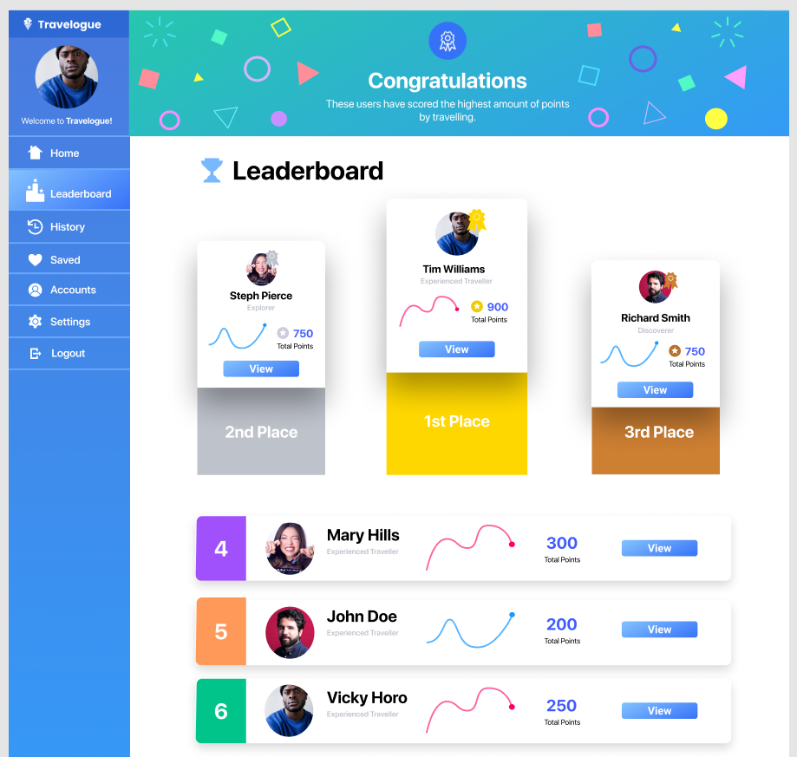

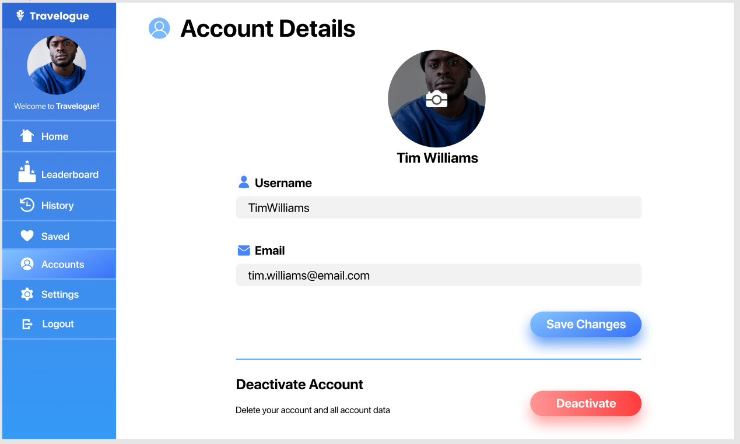

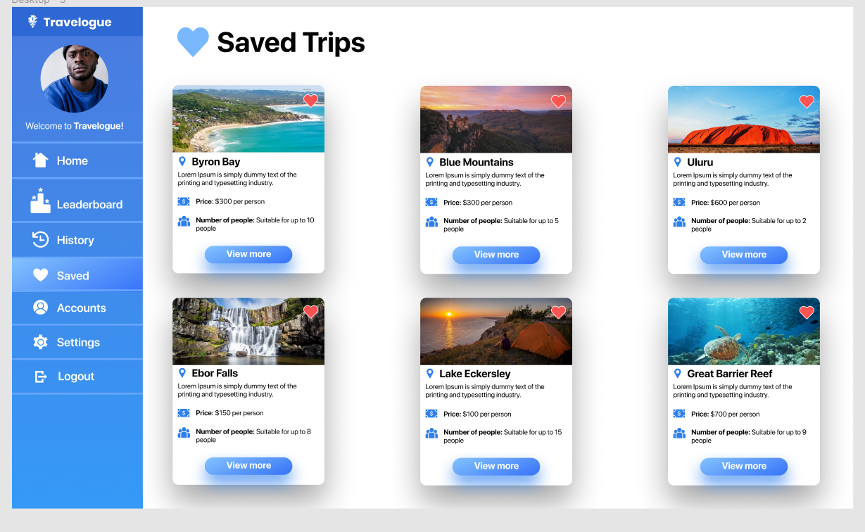

**Coding**

Integrated boiler plate code for registration page using typescript and functional hooks and components with regEx for checking valid emails and password, which would help for the authentication process. Below contains a snippet of the code and a commit link which is: https://github.com/Studio-3A/Mobile/commit/035aa1d9b99943f774ef01a77aca1a41c1393d77

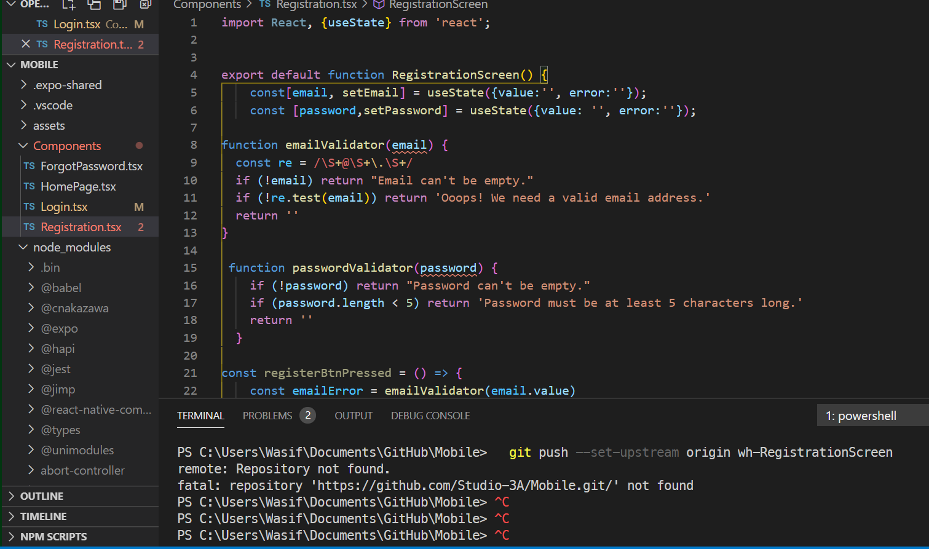

**Development Research**

Studied about Test Driven Development such as their techniques and types of available tools that are available to use for coding. The documentation of the research has been uploaded with a commit hash of: b80554cc8c120d2e6b72038c3486beb6f56d0c66

**Commit URL**: https://github.com/Studio-3A/Front-end/commit/b80554cc8c120d2e6b72038c3486beb6f56d0c66